 | ISSN: 2476-6909; Modares. Mech. Eng. *;*(*):*-*  Modares Mechanical Engineering  DOI:  journal homepage: mme.modares.ac.ir |  |  | 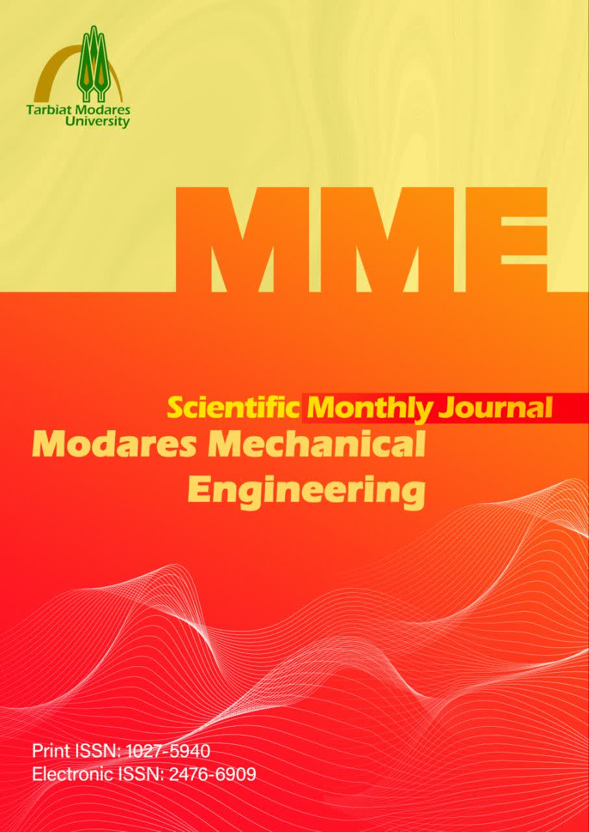

Title
First Author¹, Second Author^{2*} , Third Author³
¹ Mechanical Engineering Department, Tarbiat Modares University, Tehran, Iran
² Chemical Engineering Department, Tarbiat Modares University, Tehran, Iran
³ Civil Engineering Department, Tarbiat Modares University, Tehran, Iran
A R T I C L E I N F O |  |  | A B S T R A C T
Article Type  Original Research |  |  | Abstract text (200-250)
Article History
Received: **** **, *
Revised: **** **, *
Accepted: *** **, *
ePublished: **** **, *
 |  |  | Keywords: Words, … (3-5)
How to cite this article
Names, Title. Modares Mechanical Engineering; *(*): ****-****.

*Corresponding author’s email: …….@modares.ac.ir
*Corresponding ORCID ID:

Copyright© 2026, TMU Press. This open-access article is published under the terms of the Creative Commons Attribution-NonCommercial 4.0 International License which permits Share (copy and redistribute the material in any medium or format) and Adapt (remix, transform, and build upon the material) under the Attribution-NonCommercial terms.

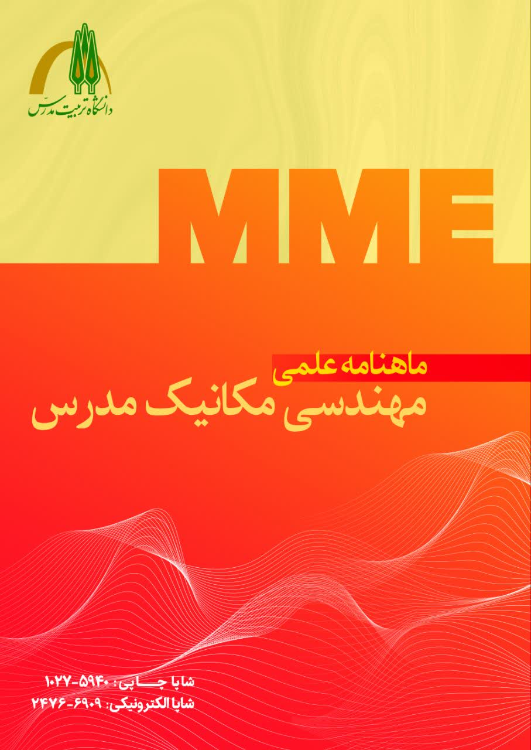 | شاپا: 6909-2476؛ مهندسی مکانیک مدرس. *؛*(*):*_*  مهندسی مکانیک مدرس  DOI:  صفحه اصلی مجله: mme.modares.ac.ir |  | 

عنوان
نويسنده اول¹، نويسنده دوم^{2*} ، نويسنده سوم³
¹ گروه مهندسی مکانیک، دانشگاه تربیت مدرس، تهران، ایران
² گروه مهندسی شیمی، دانشگاه تربیت مدرس، تهران، ایران
³ گروه مهندسی عمران، دانشگاه تربیت مدرس، تهران، ایران
چکیده |  |  | اطلاعات مقاله
متن چکیده (200-250) |  |  | نوع مقاله  مقاله پژوهشی
تاریخچه مقاله
دریافت: **/**/****
بازنگری: **/**/****
پذیرش: **/**/****
ارائه آنلاین: **/**/****
کلیدواژه‌ها: کلمات،... (3-5)
نحوه ارجاع به این مقاله
اسامی نویسندگان، عنوان مقاله، مهندسی مکانیک مدرس. * (*): ****-****.

*پست الکترونیکی نویسنده عهده‌دار مکاتبات: …….@modares.ac.ir
*شناسه ارکید نویسنده عهده‌دار مکاتبات:
Copyright© 2026, TMU Press. This open-access article is published under the terms of the Creative Commons Attribution-NonCommercial 4.0 International License which permits Share (copy and redistribute the material in any medium or format) and Adapt (remix, transform, and build upon the material) under the Attribution-NonCommercial terms.

1- Introduction (Heading 1)
Please use this template to prepare your article. The page size and margins are already set in this format. Authors simply need to save a copy of this file on their computer. Then, by copying and pasting their text into this file, they can apply the appropriate styles. Additionally, after pasting the text into each section of the article, you can directly apply the corresponding style using the following path: (Main Text).
Paste option → match with Destination format
When using punctuation marks such as , : . ; etc., please remember that all such marks should be written without a space before and with a single space after the preceding and following words, respectively.
The journal accepts articles in both Persian and English. Articles must be research-based and original, resulting from the author's own work. Furthermore, the article must not have been previously published or submitted simultaneously to other journals or conference proceedings.
The submitted articles must include the following sections:
a) Full title of the article, with a maximum of 20 words.
b) Name(s) of the author(s). The corresponding author should be marked with an asterisk (*). It is recommended that the corresponding author be an official member of a recognized institution and use the institutional email address for all article-related correspondence.
c) The affiliated institution of each author along with a brief address.
d) Full contact information for the corresponding author, including mailing address, phone number, email address, and ORCID ID.
e) Abstract of the article.
f) Keywords.
g) Main body of the article, including Introduction, Problem Statement, Methodology, Interpretation, Results Analysis, Conclusion, Acknowledgments, List of Symbols and Abbreviations, and References.
The authors are solely responsible for the accuracy of the content. The corresponding author is legally accountable for all aspects of the manuscript.

1-1- Quantities (Heading 2)
Quantities and values must be expressed using the International System of Units (SI metric). The use of units from other systems is not permitted; if necessary, their equivalents may be provided in parentheses.

1-2- Citing References
References should be cited in the text using square brackets, starting with [1], and subsequent references should follow in order. References must be numbered according to the order of their appearance in the text, and it is not permitted to cite reference [3] before reference [2].
When citing multiple consecutive sources, they can be grouped together as [2–4] instead of listing them individually. For citing two or more non-consecutive sources, separate them with commas within the brackets, e.g., [2, 5, 7].

1-2-1- Incorrect Citing (Heading 2)
Avoid citing references in the following manner: “Many researchers have studied this topic [2–20].”

1-3- Equations
Equations should be presented in tables as shown above. Use the equation editor tool for this purpose. The equation editor should also be used when referring to each parameter within the text.
$$A=πr^{2}$$ | (1)
where A is the cross-sectional area, and r is the cross-sectional radius.

2- Guidelines for Preparing Figures
One of the key features of a good article, often noticed at first glance, is the quality of its figures. Therefore, it is essential that these figures be prepared with greater care. Accordingly, a set of guidelines for figure preparation has been developed by the Modares Mechanical Engineering Journal, as outlined below. Authors are required to prepare their figures in accordance with these guidelines.
- Given the column width of the article, the width of the figures must be 75 mm. If a larger image is necessary, the width must be 160 mm (i.e., the width of two columns).
- All numbers and labels within the figures must be legible, and the font size and elements should be proportionate to each other and consistent with the main text.
- A uniform and consistent style should be maintained across all figures in the article.
- For multi-part figures (e.g., parts a, b, etc.), the layout should follow a left-to-right arrangement.
- If figures are taken from software such as SolidWorks, Abaqus, etc., ensure that the background of the images is white.
Examples of both proper and improper figures are provided in Figures 1 to 4.

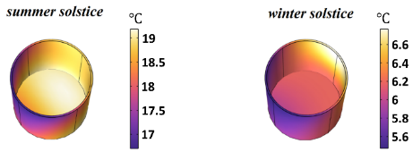
Fig. 1 Correct example

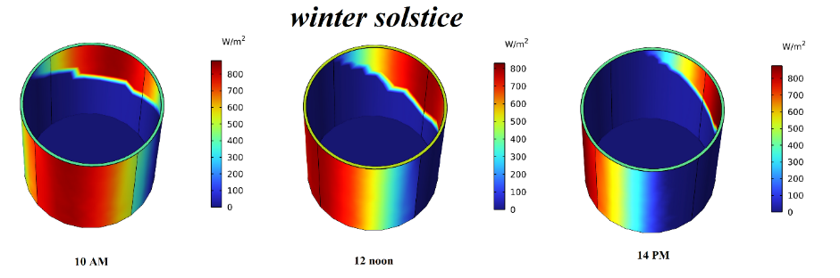
Fig.2 Correct example of a proper two-column image

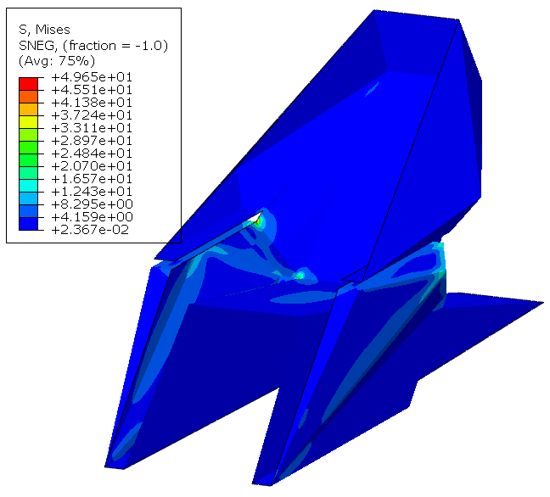 | 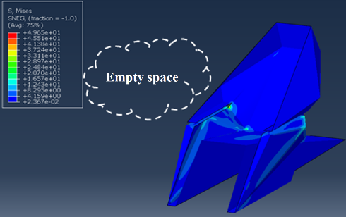
(b) | (a)
Fig.3 Correct and incorrect example of the figure

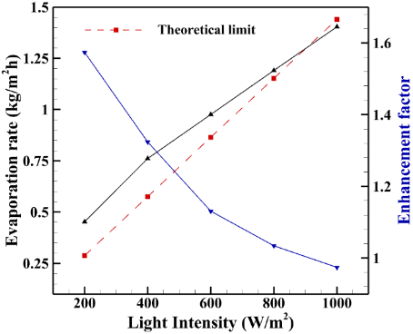
Fig.4 Correct example of a diagram

Use the "Figure and Table Caption" style for figure titles. It is also recommended to place figures within a table and then use the No Border option to remove the table lines. To view such tables, the following option must be enabled.
Layout → View Gridlines

3- Guidelines for Preparing Tables
To create tables, select the following path. For the table title, use the "Figure and Table Caption" style, and make the table title and number bold. Also, apply the "Table Text" style to the content inside the table.
Table design → Table Style → MME

Table 1 Sample table accepted by the journal
Number
1
2
3

4- Writing Rules
Efforts should be made to use clear, concise, and straightforward sentences in the article text, avoiding complex and nested sentences. Separating the different components of a sentence plays a significant role in enhancing its clarity.
If necessary, the list of symbols and abbreviations should be included at the end of the article, before the references. This list should be organized as a two-column table arranged in alphabetical order, with each row containing the symbol and its description (including dimensions) respectively. Example:

Nomenclature
P | Pressure (Pa)
Pr | Prandtl number
u_{j} | Velocity (m/s)
T | Temperature (K)
Note: In the list of symbols, first list the English symbols in alphabetical order, followed by the Greek symbols in alphabetical order. The Greek alphabet, including both lowercase and uppercase letters, is as follows:
α, Α, β, B, γ, Γ, δ, Δ, ε, Ε, ζ, Ζ, η, Η, θ, Θ, ι, Ι, κ, Κ, λ, Λ, μ, Μ, ν, Ν, ξ, Ξ, ο, Ο, π, Π, ρ, Ρ, σ, Σ, τ, Τ, υ, Υ, φ, Φ, χ, Χ, ψ, Ψ, ω, Ω.

4- Conclusion
This template has been prepared solely to accelerate the layout process, so that researchers' articles can be published in a shorter time. We hope you will assist the editorial team in this process.

Artificial Intelligence Statement: An explicit statement regarding the use or non-use of artificial intelligence tools must be included. This should be provided in the form of a statement on the use of generative artificial intelligence.
Acknowledgements: An acknowledgements section must be included to express appreciation to collaborators or cooperating organizations. (Optional)
Funding: Clear information regarding the financial sponsor of the research or the source of funding must be provided in accordance with the guidelines for declaring funding sources.
CRediT Authorship Contribution: The specific role of each author must be clearly stated based on the CRediT standard.
Conflict of Interest: A conflict of interest statement, including a declaration of no conflict of interest where applicable, must be included in accordance with the commitment form.

References
Use IEEE style for references
Make sure to include the DOI at the end of each reference.
[1] B. Laux and J. Rösler, "Mechanical properties of new Ni-Mn-based braze alloys for the fast epitaxial braze repair of single-crystalline Ni-base superalloys," Advanced Materials Research, vol. 278, pp. 479-484, 2011. doi:10.4028/www.scientific.net/AMR.278.479
[2] H.-y. Xu, Z.-y. Ye, and A.-m. Shi, "Numerical study of propeller slipstream based on unstructured dynamic overset grids," Journal of Aircraft, vol. 49, no. 2, pp. 384-389, 2012. doi:10.2514/1.C031097
[3] A. Rabiee, F. Ghadak, and M. Doostdar, "Investigation of Reynolds Number Effect on Dimensionless Coefficients of Three-Hole Yawmeter Probe Using Experimental and SPM Analytical Methods," Modares Mechanical Engineering, vol. 20, no. 7, pp. 1829-1839, 2020.
[5] F. M. Marcu, "Semiactive cab suspension control for semitruck applications," 2009.
[6] Aeppli, A. Gear Planing Machine, 1949: Patent US2479287, USA.
[7] D. A. Stephenson and J. S. Agapiou, Metal cutting theory and practice. CRC press, 2018.

